GOOGLE SITES ANALYSIS

SUBMITTED BY- 500095789

"The Culinary Coop" was founded by a group of chefs who shared a passion for creating fresh, delicious cuisine using locally-sourced ingredients. They wanted to create a restaurant that would celebrate the diversity and flavors of the surrounding community, while also promoting sustainable and ethical farming practices.

To bring their vision to life, the founders pooled their resources and formed a cooperative. They converted an old barn on the outskirts of town into a cozy, rustic restaurant, where diners could enjoy farm-to-table meals made with ingredients from nearby farms and gardens.

Over time, the restaurant became known not just for its delicious food, but also for its commitment to supporting local agriculture and building a stronger, more resilient community. It became a popular gathering place for farmers, foodies, and anyone who shared the founders' passion for good food and sustainable living.

Today, "Culinary Coop" continues to thrive, offering a unique dining experience that combines fresh, flavorful cuisine with a deep commitment to community and sustainability

SITE LINK: [THE CULINARY COOP](https://sites.google.com/view/theculinarycoop/home)

**Site Overview:**





**What is Google Analytics?**Google Analytics is a free web analytics service provided by Google that assists website owners and marketers in tracking and analyzing website traffic, user behavior, and other website performance indicators.

Google Analytics gives a plethora of data and insights into how your website's users interact with it. You can use this data to determine which pages on your website are popular, which pages have a high bounce rate, how long users stay on your website, which traffic sources drive the most traffic to your website, and much more.

Here are the key benefits of using google analytics:

1. Here are some of the primary advantages of using Google Analytics:
2. Understand your audience: Google Analytics provides insights into your website visitors' demographics, geographic area, interests, and behavior.
3. Monitor website performance: You may monitor how users interact with your website, which pages are popular, which pages have a high bounce rate, and other information.
4. Improve the user experience of your website: By analyzing user behavior, you can find chances to improve the usability, navigation, and content of your website in order to better fulfill the needs of your visitors.
5. Google Analytics can track the efficacy of your marketing activities, including sponsored search, social media, email marketing, and others.
6. Make data-driven decisions: With real-time data and insights at your fingertips, you can make data-driven decisions to improve the effectiveness of your website and marketing initiatives.

Overall, Google Analytics is a useful tool for optimizing your website, improving user experience, and driving more traffic and conversions.

Site Analysis:

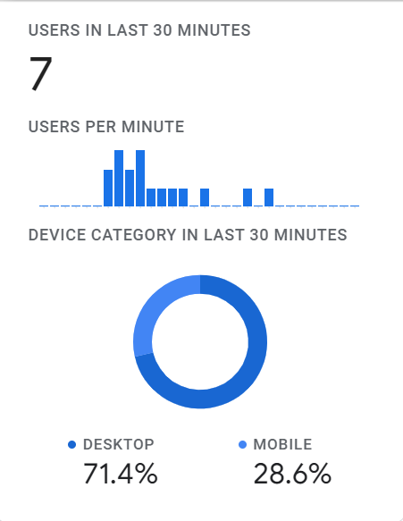

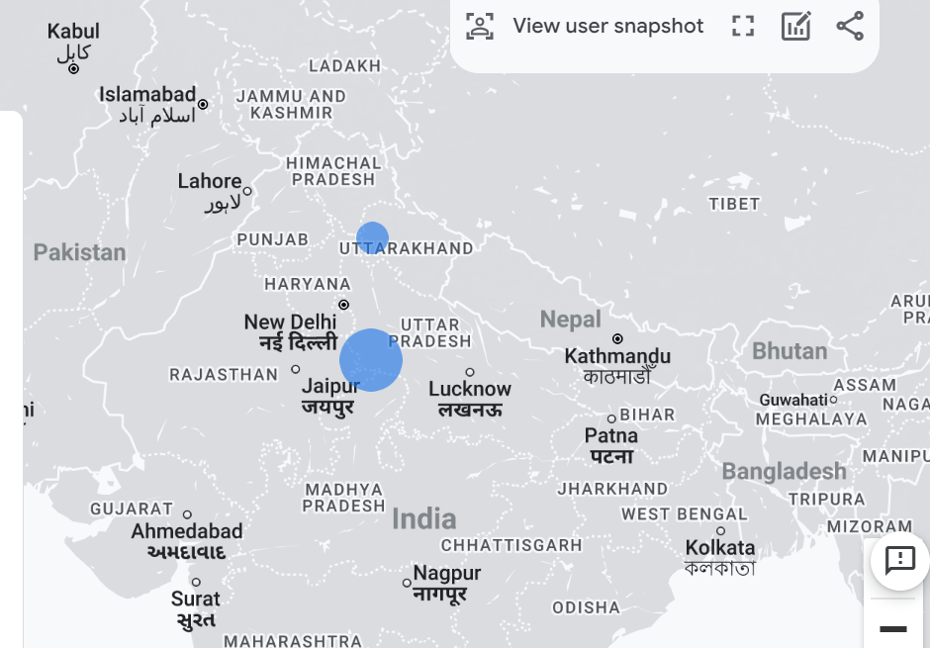

From the above given screenshots we can understand that in the past 30 mins there were 7 users, 71.4% from desktop, 28.6% from mobile. The geomap shows that the user were from India and to be exact Agra and Dehradun.

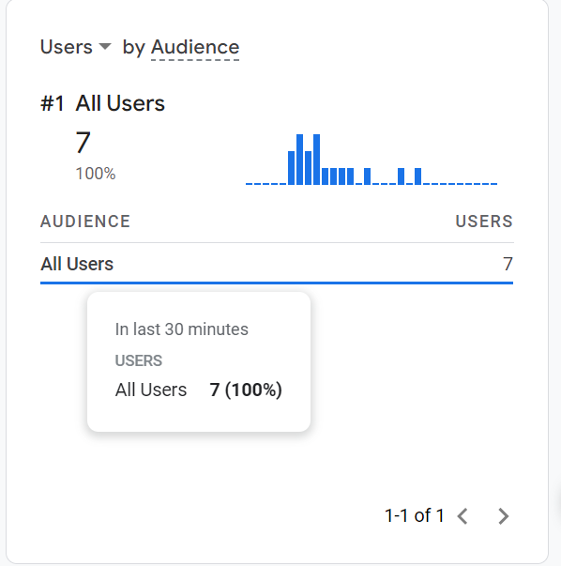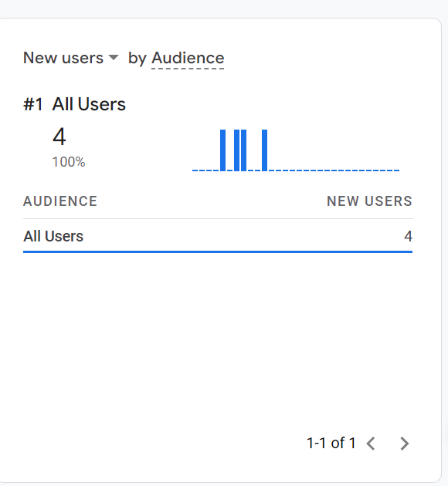

The above ss shows that there were a total of 7 users and 4 new users in the past 30 mins.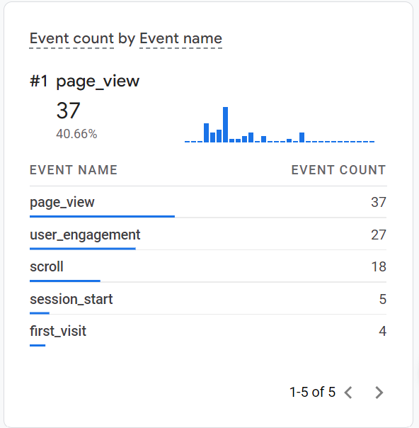

An "event" in Google Analytics is a user interaction with content that may be recorded separately from a pageview. Event monitoring allows you to track how visitors interact with items on your website, such as link clicks, file downloads, form submissions, video plays, and so on.

The "event count" in Google Analytics refers to the number of times an event on your website has been triggered. The overall event count for a certain event category, action, or label may be found in Google Analytics' Events report.

The event name SCROLL means how many times the page has been scrolled, which is 18 times. Page view means how many times the home screen came on, that was 37 times. User_Engagemnet- It is a term used to define the level of contact and involvement that your website's users have with it, which has a count of 27. Session start is when a new person comes to the site and this ends when the user exits the site, there are 5 session_start. First visit is 4.

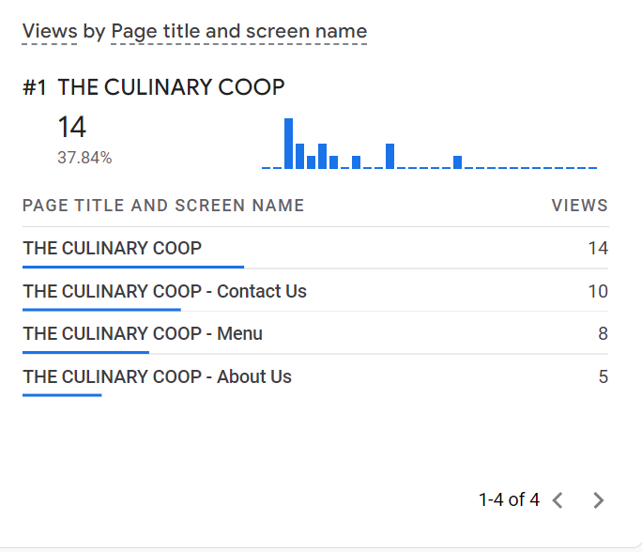

The ss beside talks about the views on different suboptions on the website, described by Pge title and screen name and views.